**Exercise 1: Implementing the Singleton Pattern**

**Scenario:**

You need to ensure that a logging utility class in your application has only one instance throughout the application lifecycle to ensure consistent logging.

**Steps:**

1. **Create a New Java Project:**
   * Create a new Java project named **SingletonPatternExample**.
2. **Define a Singleton Class:**
   * Create a class named Logger that has a private static instance of itself.
   * Ensure the constructor of Logger is private.
   * Provide a public static method to get the instance of the Logger class.
3. **Implement the Singleton Pattern:**
   * Write code to ensure that the Logger class follows the Singleton design pattern.
4. **Test the Singleton Implementation:**
   * Create a test class to verify that only one instance of Logger is created and used across the application.

**Code:**

**Logger Class:**

package com.cognizant;

public class Logger {

// Private static instance of the same class

private static Logger *instance*;

// Private constructor

private Logger() {

System.***out***.println("Logger instance created.");

}

// Public static method to return the single instance

public static Logger getInstance() {

if (*instance* == null) {

*instance* = new Logger();

}

return *instance*;

}

// Sample logging method

public void log(String message) {

System.***out***.println("[LOG]: " + message);

}

}

**SingletonTest Class:**

package com.cognizant;

public class SingletonTest {

public static void main(String[] args) {

// Get the first instance

Logger logger1 = Logger.*getInstance*();

logger1.log("First log message");

// Get the second instance

Logger logger2 = Logger.*getInstance*();

logger2.log("Second log message");

// Check if both references point to the same object

if (logger1 == logger2) {

System.***out***.println("Both logger instances are the same (Singleton works).");

} else {

System.***out***.println("Different logger instances (Singleton failed).");

}

}

}

**Output Screenshot:**

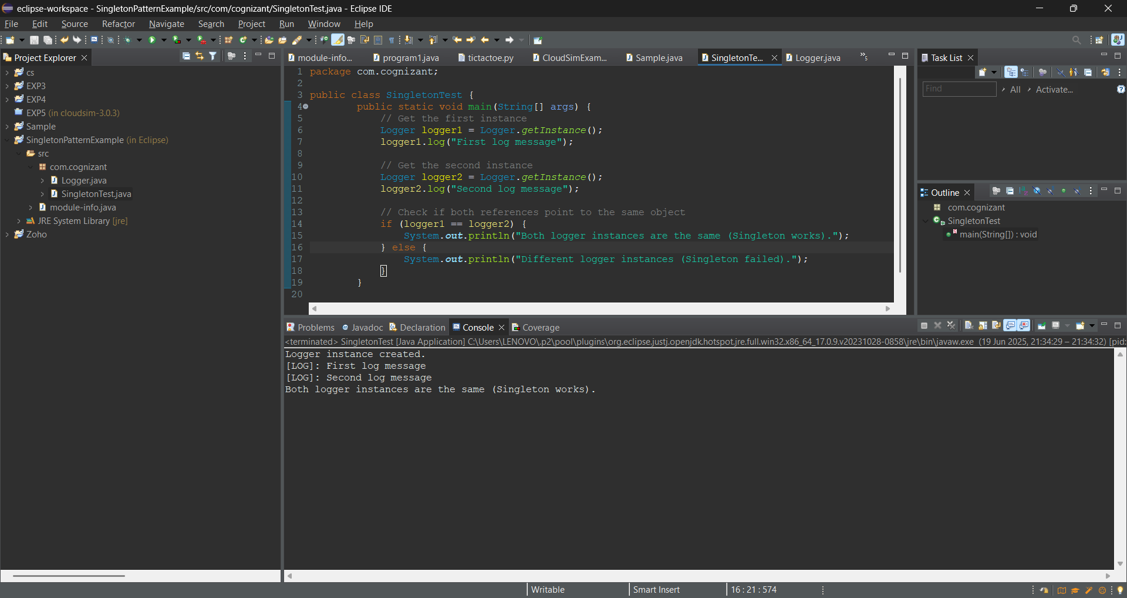

**Exercise 2: Implementing the Factory Method Pattern**

**Scenario:**

You are developing a document management system that needs to create different types of documents (e.g., Word, PDF, Excel). Use the Factory Method Pattern to achieve this.

**Steps:**

1. **Create a New Java Project:**
   * Create a new Java project named **FactoryMethodPatternExample**.
2. **Define Document Classes:**
   * Create interfaces or abstract classes for different document types such as **WordDocument**, **PdfDocument**, and **ExcelDocument**.
3. **Create Concrete Document Classes:**
   * Implement concrete classes for each document type that implements or extends the above interfaces or abstract classes.
4. **Implement the Factory Method:**
   * Create an abstract class **DocumentFactory** with a method **createDocument()**.
   * Create concrete factory classes for each document type that extends DocumentFactory and implements the **createDocument()** method.
5. **Test the Factory Method Implementation:**
   * Create a test class to demonstrate the creation of different document types using the factory method.

**Code:**

**Interface: Document**

package com.FactoryMethodPatternExample;

public interface Document {

void open();

}

**WordDocument Class:**

package com.FactoryMethodPatternExample;

public class WordDocumentFactory extends DocumentFactory{

*@Override*

public Document createDocument() {

return new WordDocument();

}

}

**PdfDocument Class:**

package com.FactoryMethodPatternExample;

public class PdfDocument implements Document{

private static int *count* = 0;

private int id;

public PdfDocument() {

id = ++*count*;

}

*@Override*

public void open() {

System.***out***.println("Opening PDF Document #" + id);

}

}

**ExcelDocument Class:**

package com.FactoryMethodPatternExample;

public class ExcelDocument implements Document{

private static int *count* = 0;

private int id;

public ExcelDocument() {

id = ++*count*;

}

*@Override*

public void open() {

System.***out***.println("Opening Excel Document #" + id);

}

}

**Abstract DocumentFactory Class:**

package com.FactoryMethodPatternExample;

public abstract class DocumentFactory {

public abstract Document createDocument();

}

**WordDocumentFactory Class:**

package com.FactoryMethodPatternExample;

public class WordDocumentFactory extends DocumentFactory{

*@Override*

public Document createDocument() {

return new WordDocument();

}

}

**PdfDocumentFactory Class:**

package com.FactoryMethodPatternExample;

public class PdfDocumentFactory extends DocumentFactory{

*@Override*

public Document createDocument() {

return new PdfDocument();

}

}

**ExcelDocumentFactory Class:**

package com.FactoryMethodPatternExample;

public class ExcelDocumentFactory extends DocumentFactory{

*@Override*

public Document createDocument() {

return new ExcelDocument();

}

}

**FactoryPatternTest Class:**

package com.FactoryMethodPatternExample;

public class FactoryPatternTest {

public static void main(String[] args) {

DocumentFactory wordFactory = new WordDocumentFactory();

DocumentFactory pdfFactory = new PdfDocumentFactory();

DocumentFactory excelFactory = new ExcelDocumentFactory();

Document word1 = wordFactory.createDocument();

Document word2 = wordFactory.createDocument();

Document pdf1 = pdfFactory.createDocument();

Document excel1 = excelFactory.createDocument();

Document pdf2 = pdfFactory.createDocument();

word1.open();

word2.open();

pdf1.open();

excel1.open();

pdf2.open(); }

}

**Output Screenshot:**

